Valor Shopify Custom App Documentation
November 24, 2021

Overview
The contents below will be providing an overview documentation on how to configure the Shopify custom apps for Valor, STLTH, and NYX.
Each application follows a similar system architecture and deployment method, so the same configuration apply for all.

PM2
https://pm2.keymetrics.io/docs/usage/quick-start/
PM2 is a daemon process manager that helps manage and keep each Shopify custom app running 24/7.
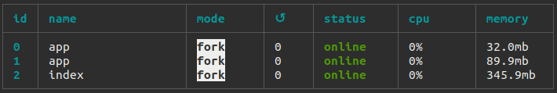The apps running on Valor's server through PM2
List of Commands Used:
Start an app
$ pm2 start app.js

Managing processes
$ pm2 restart app.js
$ pm2 reload app.js
$ pm2 stop app.js
$ pm2 delete app.js

List managed applications
$ pm2 list

View logs
$ pm2 logs

List of Servers
Valor - ubuntu@ec2-3-97-74-6.ca-central-1.compute.amazonaws.com
STLTH - ubuntu@ec2-52-60-62-136.ca-central-1.compute.amazonaws.com
NYX - ubuntu@ec2-99-79-58-134.ca-central-1.compute.amazonaws.com
STLTH DB – stlth-bold-app.cszi0td6zk5e.ca-central-1.rds.amazonaws.com

Valor Apps
Both of the Valor apps are stable in terms of the applications themselves. There are times where the server will need to be restarted, resulting in pm2 services stopping.

Valor CSV Upload
https://valordistributions.com/pages/order-importer
Service Location
~/valor-csv-upload/app.js

The Valor CSV Upload app is used for customers to create quick bulk orders. It is not a Shopify Custom App, but just a lightweight Node.js server, it’s main purpose is to make calls to Shopify’s API. It’s currently stable and should continue to in the future.

Valor Customer Orders
https://valordistributions.com/account
Service Location
~/valor-customer-orders/app.js
The Valor Customer Orders app is used to display a list of customer orders on the account page. Similar to the CSV Upload app, it is not a Shopify Custom App, but a lightweight Node.js server. It’s currently stable and should continue to in the future.

STLTH Apps

STLTH Custom Pricing
https://app.stlthvape.com/auth?shop=vpempire-com.myshopify.com
The STLTH Custom Pricing app was created to replace BOLD’s custom pricing app. The main functionality resides on the admin section of the application, where you can set custom pricing for customers containing certain tags for various types of products.
If there are new products added for a collection, the price groups are going to have to be deleted for that collection. Recreating the price groups will then create the new variants. We should look into creating an sync function for the collections to handle new products.
The application works independently from the customer facing feature. The application primarily works as an inventory manager.

NYX Apps

NYX In-Store Pickup
https://www.nyxecigs.com/cart
Service Location
~/apps/nyx-instore-pickup/server/index.js

The In Store Pickup application is a Shopify Custom App, containing features on both the admin and storefont sections. On the cart page, customers can select the In Store Pickup option and check what locations can fulfill their order. Once they select a location and checkout, store managers will be notified via Discord bot that an in store pickup request has been placed. The store manager can view all in store pickup orders through the Shopify app and contact customers whenever their orders are ready.
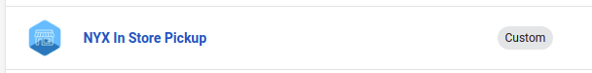
Note: The login functionality for the website currently relies on the app because we create and store an access token for checkout.

NYX Promo Card (Coil Stamp)
Service Location – ON VALOR SERVER
~/NYX-Promo-Card/server/index.js

The NYX Promo Card app is used to give promos to customers whenever they reach a certain amount of products, they can get free rewards. This application runs as a Shopify Custom App and is strictly used on the admin side only. It is stored on the Valor EC2 server because the NYX one was not yet created when it was deployed.


